Can I stream to Youtube from a USB camera?
Yes you can!
It can seem a little daunting at first, but streaming to YouTube from a USB camera is actually very easy. To get started the few things you will need are an operational HuddleCam and an active YouTube account.
Let’s start by logging into YouTube.
You should be able to click on 3 little horizontal lines in the upper left of the home screen.
Go to “My Channel”
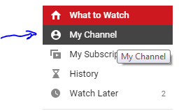
Now, you should be able to select the “Video Manager” tab from below the search bar.
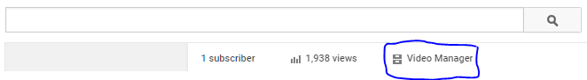
Go to “Live Events” and click the button on the top-right to create “New Live Event”
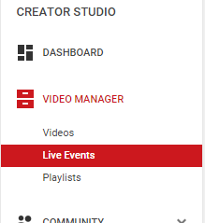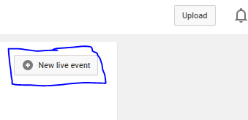
Next name your event, schedule a time for it, and set as public or private.
For the “Type”, make sure it is set to “Custom”.
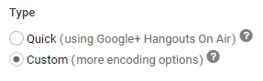
Next, choose a bit rate that suits your available bandwidth.
From testing with the cameras it has been found that 720P does an excellent job of providing a quality streaming experience without utilizing too much bandwidth.
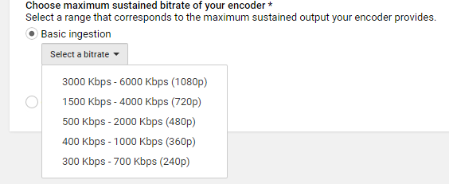
Once you select your bitrate you will have to choose your Encoder.
In this how to guide we will be looking at Wirecast as an encoder.
Select Wirecast for Youtube from the dropdown menu.
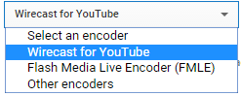
Next, you will be instructed to download the latest version of the software from Telestream.
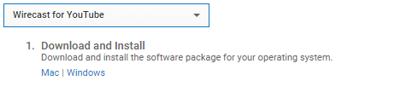

Once that is completed, open up your Wirecast software. You should see a gray “gear” icon in the upper middle of the screen. Click this to set up your Youtube streaming settings.
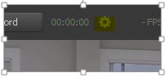

This will bring up your Youtube page in Wirecast.
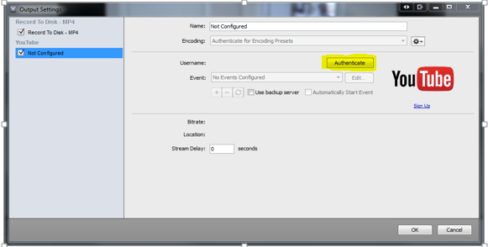
Once here hit the “Authenticate” button. This should automatically bring up a page that asks you for permission for Wirecast to manage your Youtube account; click accept.
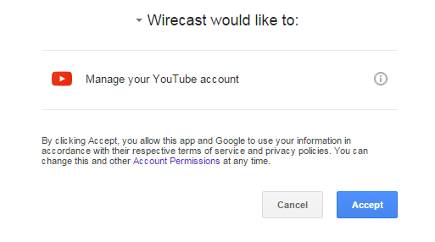

Now, select your camera from the master layer available to you (it should be only one unless you pay for more) You may have to push the gray “plus sign” to add a new camera in order to be able to see your USB camera.
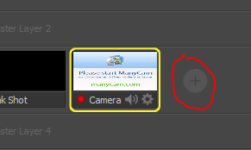

Now you should be good to press the gray “stream” button at the top
Now, go back to Youtube Live and select the “Live Control Room” tab at the top.
Start the preview stream by clicking on the “Preview” button
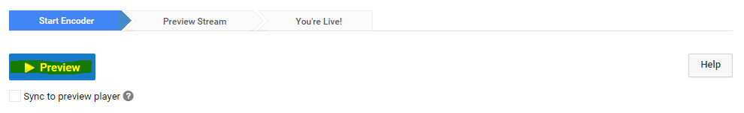
Then you will be able to start the actual stream by clicking “Start Streaming”
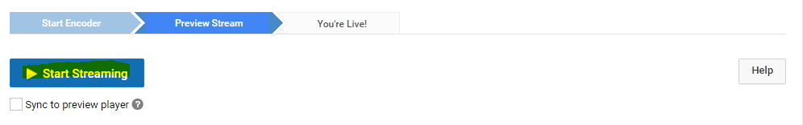
Once the stream has been initialized you can scroll down to the public view window in the YouTube Live page and monitor your stream by clicking the play icon. From this same “Public View” frame you can also get a shareable link to use for distribution of your live content.
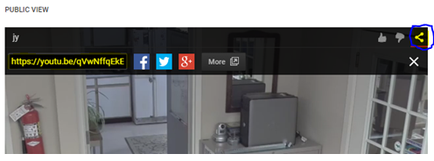
You’re now live streaming!
Special Note: The stream will not stop unless you go back up to the top of your “Live Control Room” page in YouTube Live and click “Stop Streaming”.
